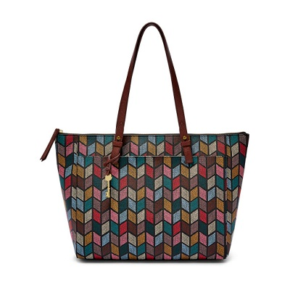

Rachel Tote

PRODUCT DETAILS

**Silhouette: Tote With Zipper**

**Tech Compatibility: 13" Laptop**

**Exterior Material: 100% PVC/Polyurethane Trim**

**Interior Details: 1 Zipper Pocket, 2 Slide Pockets**

**Measurements: 14"L x 4"W x 13"H**

**Handles/Straps: 2 Handles**